# 🩺 Medical Image Analysis Report

## 1. Image Type & Region

- **Modality:** X-ray (Radiograph)

- **Region:** Chest, PA (Posteroanterior) view

- **Quality:** Adequate. The image demonstrates good penetration, allowing for visualization of both lung fields and mediastinal structures.

## 2. Possible Category

- Effusion

## 3. Key Findings

- **Right Hemithorax:** A large opacity is seen occupying the lower right hemithorax. The density is homogenous, suggesting fluid accumulation.

- **Mediastinum:** There appears to be a shift of the mediastinum towards the left side. This shift suggests a mass effect or pressure from the right hemithorax.

- **Costophrenic Angle:** The right costophrenic angle is blunted, which is consistent with fluid accumulation (effusion).

- **Lung Fields:** The left lung field appears clear, with no obvious infiltrates, nodules, or masses.

- **Cardiac Silhouette:** The cardiac silhouette is normal in size and position, except for the shift caused by the mediastinal displacement.

## 4. Diagnostic Assessment

- **Primary Diagnosis:** Right-sided pleural effusion with moderate confidence.

- **Supporting Evidence:** Homogenous opacity in the lower right hemithorax, blunting of the right costophrenic angle.

- **Differential Diagnoses:**

1. **Empyema:** While less likely without further clinical context, an empyema (pus in the pleural space) could present similarly.

2. **Hemothorax:** Bleeding into the pleural space could also produce similar radiographic findings.

3. **Consolidation:** Although consolidation can present as opacity, the homogenous nature and presence of pleural effusion features make it less likely.

- **Critical/Urgent Findings:** The mediastinal shift indicates significant pressure within the right hemithorax and could compromise respiratory function. Further evaluation is warranted.

## 5. Patient-Friendly Explanation

This X-ray shows a picture of your chest. On the right side of your chest, there's a large white area that shouldn't be there. This looks like fluid has built up around your lung, like water filling a container. Because of this fluid, the structures in the middle of your chest (like your heart) are being pushed slightly to the left. The fluid needs to be investigated because it could be caused by several things, such as an infection or bleeding. It's like having a water balloon pressing on your chest; we need to figure out what's causing the balloon to inflate.

## 6. Research Context

- **Radiopaedia.org:** "Pleural effusions are abnormal accumulations of fluid within the pleural space. They may result from a variety of pathological processes which overwhelm the pleura's ability to reabsorb fluid."

- **EMCrit Project:** "Initial trifecta: History CXR, POCUS, & review of prior radiology... More advanced testing: CT scan Thoracentesis differential diagnosis All causes of pleural effusion Transudates Exudates pleural radiology POCUS Chest radiograph Subpulmonic effusion Pseudotumor"

**Conclusion:** The chest radiograph is concerning for a right-sided pleural effusion, likely requiring further investigation via thoracentesis and/or CT scan to determine the etiology and guide appropriate management. The mediastinal shift suggests a significant volume of fluid, making prompt evaluation crucial.

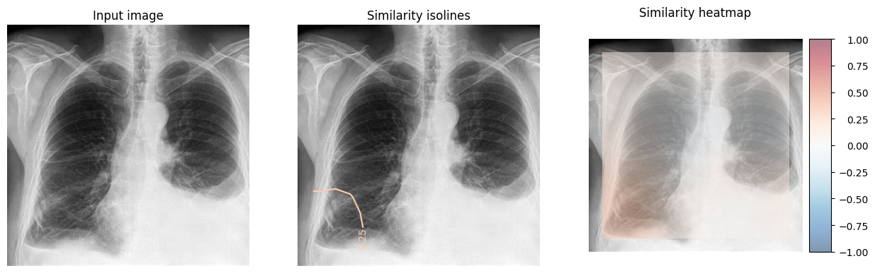

**Right Hemithorax:** A large opacity is seen occupying the lower right hemithorax. The density is homogenous, suggesting fluid accumulation.

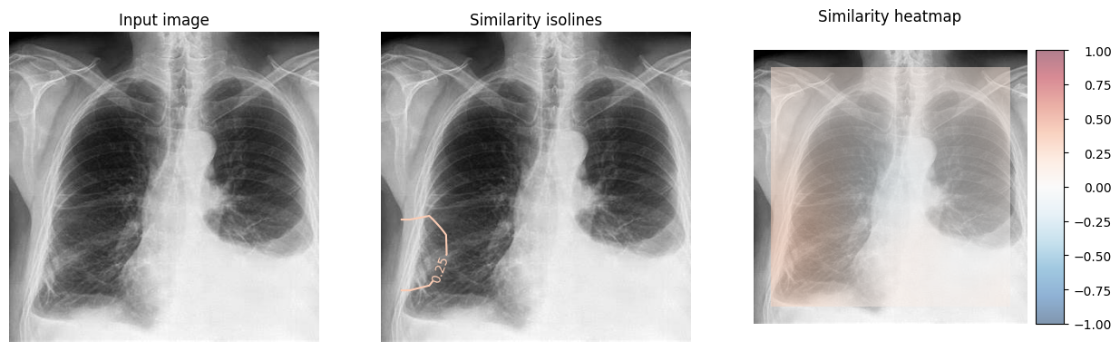

**Mediastinum:** There appears to be a shift of the mediastinum towards the left side. This shift suggests a mass effect or pressure from the right hemithorax.

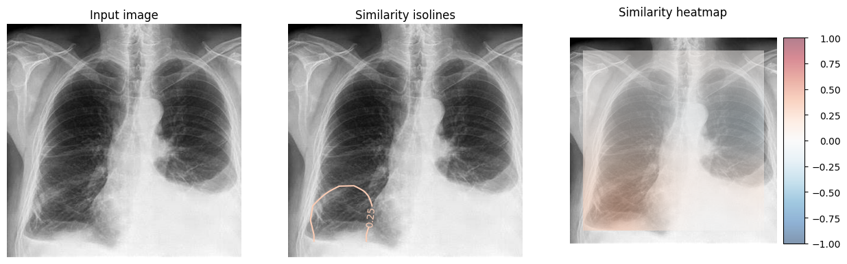

**Costophrenic Angle:** The right costophrenic angle is blunted, which is consistent with fluid accumulation (effusion).

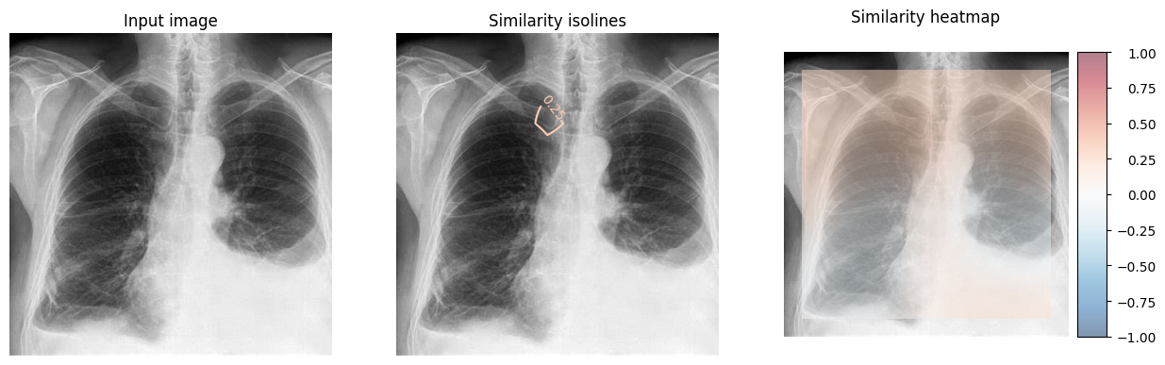

**Lung Fields:** The left lung field appears clear, with no obvious infiltrates, nodules, or masses.

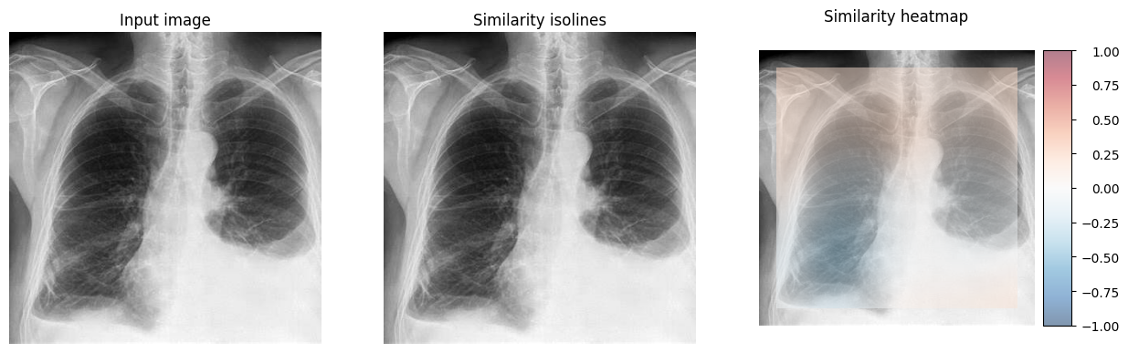

**Cardiac Silhouette:** The cardiac silhouette is normal in size and position, except for the shift caused by the mediastinal displacement.